Milestone Three

Ryan Manchanthasouk

Southern New Hampshire University

March 31st, 2019

Database Queries

In this first screen shot, the SELECT query is used to configure specific columns, and the WHERE statement is used to specify the data that is retrieved.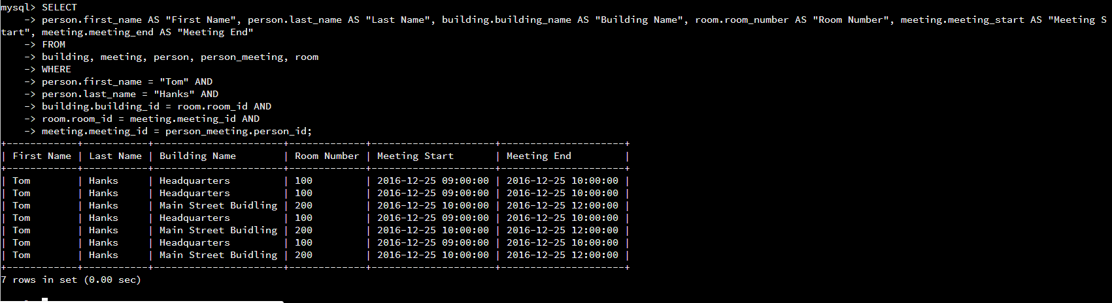

This next screen shot utilizes the same SELECT and WHERE statements, however, this time in the WHERE statement there is a specific rule that the table must follow.

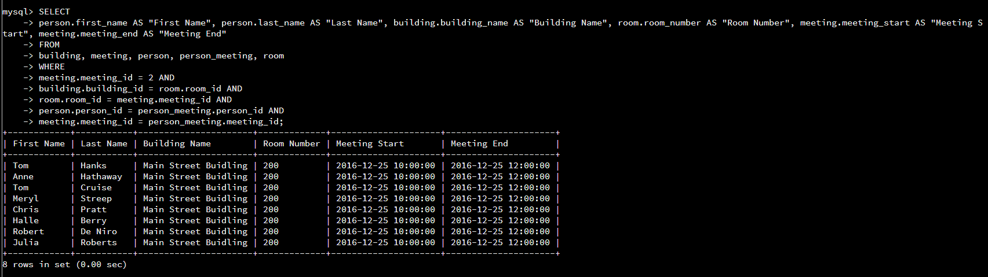

Similarly to the last screen shot, the same query is used, however, utilizing a different rule for the table to follow.

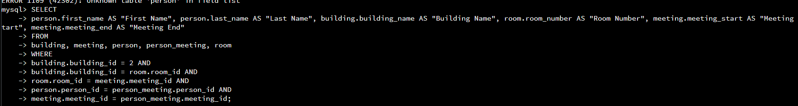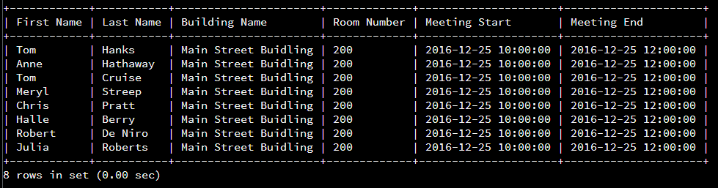

In this next screen shot, the COUNT aggregate function is used to specify the number of attendees going to each meeting. The where statement is especially important, as it specifies the rules that the table must follow to get the correct data.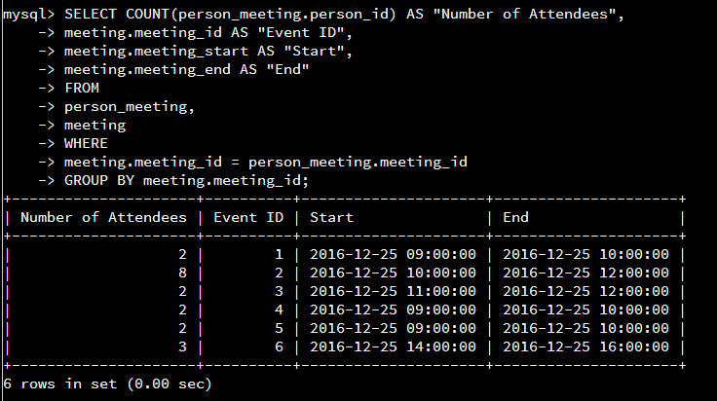

In this final screenshot, the INNER JOIN query is used to join columns from different tables, additionally the SELECT and WHERE statements are used to assist with accurate data retrieval.